

**MONASH UNIVERSITY**

**ADS2002 - DATA CHALLENGES 3**

**GROUP 1**

_________________________________________________________________________

**COUNTING MOLECULES**

_________________________________________________________________________

**CONTRIBUTORS**

JIAXING WANG

STEPHANIE WAINAINA

**SUPERVISOR**

DR SIMON CLARKE

**MAY 29, 2022**

**Executive Summary** **3**

**Introduction** **4**

Background Information 4

Aim 4

**Methodology** **5**

Image Processing 5

Data Cleaning 5

Binarization of Images 7

Blob Detection. 8

Classification and Clustering 10

Model Development 10

**Results** **15**

**Conclusion** **19**

# 

# **Executive Summary**

The problem we need to solve is an image-related manipulation problem. We are given images of molecules.The main purpose of this project is to count the number of molecules and classify them into groups. We find that the skimage library of python is especially useful to solve the problem as it has a large number of methods that we could use.And the same as ordinary number data, images also need data cleaning.Basically, we need to binarize the image by cleaning the background noise so it’s prepared for future applications.The second step is blob detection. The problem is a lot like a blob detection problem so we use different thresholds and compare which algorithm has the best result.

As for the classification part, it is more efficient to consider the problem as unsupervised learning , so whatever algorithm we use is allowed to classify, label and/or group the data points contained within the data sets without having any external guidance in performing that task. We learned the basic construction of images and discovered that each image has different features that can be taken out and analysed.For the algorithm we chose k-means-clustering and PCA . K-means algorithm in data mining starts with a first group of randomly selected centroids, which are used as the beginning points for every cluster, and then performs iterative (repetitive) calculations to optimise the positions of the centroids.

K-means is extremely useful in our problem since not only we don’t have a standard to classify the molecules but also we lack the background about the molecules, we don’t know the shape, colour,size and can’t even identify all molecules manually.

PCA(Principal component analysis) is also used because there are so many properties in each region of molecules we labelled and PCA can transform and summarise the information.

Overall,after modifying the parameters in different methods and comparing the result we are able to achieve our goal. About 70 percent of the molecules are correctly identified and divided into the same group.For future improvement we need apply different classification algorithms and/or different thresholds to identify the molecules.

# **Introduction**

## Background Information

This project looked at images of molecules that were taken under a microscope. Each image consisted of an unknown number of molecules. It should be noted that due to the format of the images provided a number of methods were applied in order to get the desired result. As such this is an image processing project. We created an algorithm that counts the number of molecules in the image and divides them into clusters of similar molecules, this was done using various machine learning algorithms.

## Aim

The objectives of this project are to remove the mean convolution window so as to isolate blobs and, to calculate properties and analyse the clusters in order to make a conclusion. This could be done by using Otsu’s method, unsupervised learning and other methods from the skimage package in python.

# **Methodology**

## **Image Processing**

The data that was provided showed us the grainy images of the molecules. As previously mentioned, the data was provided in different formats and so, we heavily relied on the Nanonispy library to read the image data in one of the common formats. Nanonispy library would generate an array of pixel data and convert it to real-space distances. This in turn made it easier to clean the data, apply filters, binarize the images and apply various machine learning algorithms to identify the clusters.

In image processing, we divided the methodology under image processing into 3 parts:

* data cleaning
* binarization of images
* blob detection.

### Data Cleaning

We created an algorithm that ensured the mean intensity was zero as the atomic level was not. This was done by showing how the mean changes over different slices. We then removed the mean change from the image and printed the edited image. The background of the edited image is significantly darker than the original image, this helps in the binarization of the image in the next step. For precautionary measures, a plot of 1 line was done to show how the frequency changes as you slice it from the left. This is shown in a step-by-step process below.

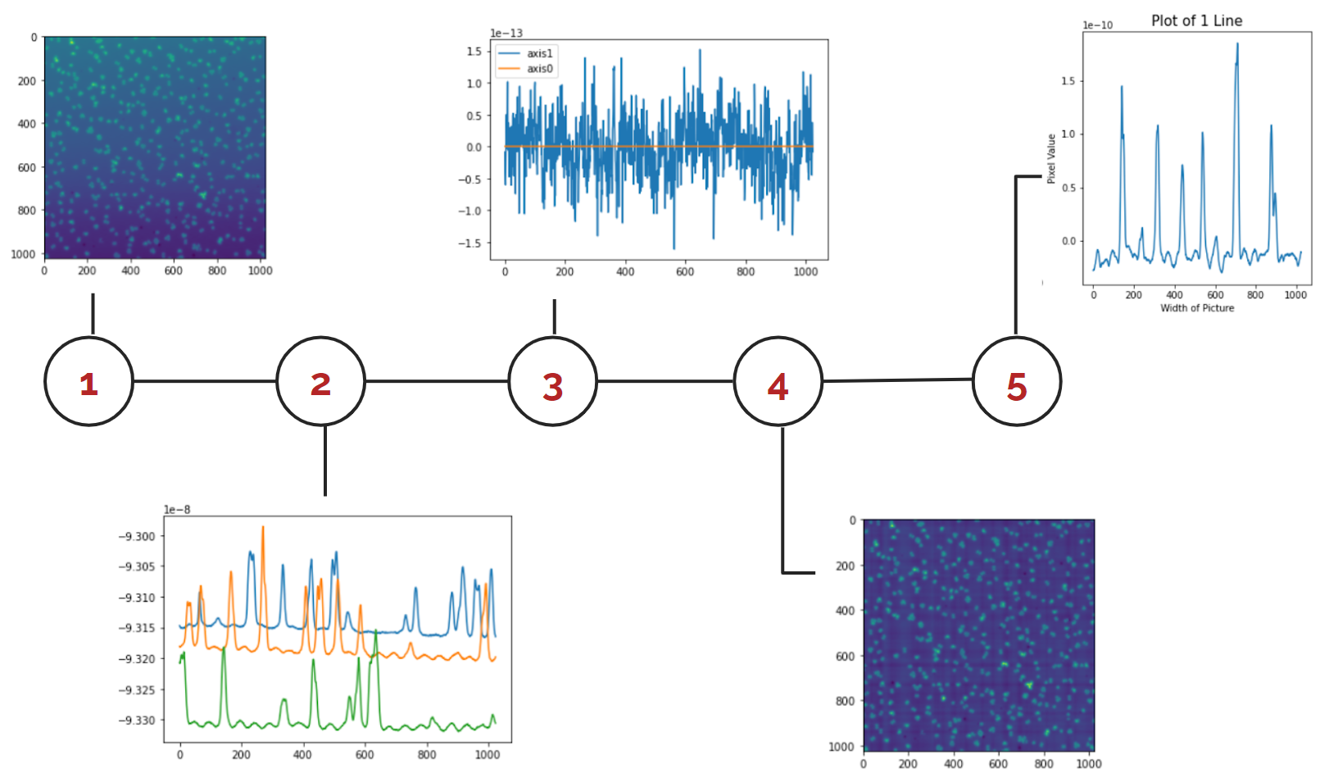

*Figure 1 data cleaning timeline*

It is worth noting that this algorithm did not work for all the images provided; However, since it worked for most of the data provided, we decided to keep it.

The algorithm created did not work for data provided in txt format for unknown reasons. Though, one can note that the plot of one line does not change even after the mean change was removed from the image as seen below. This in turn prevented any binarization to take place.

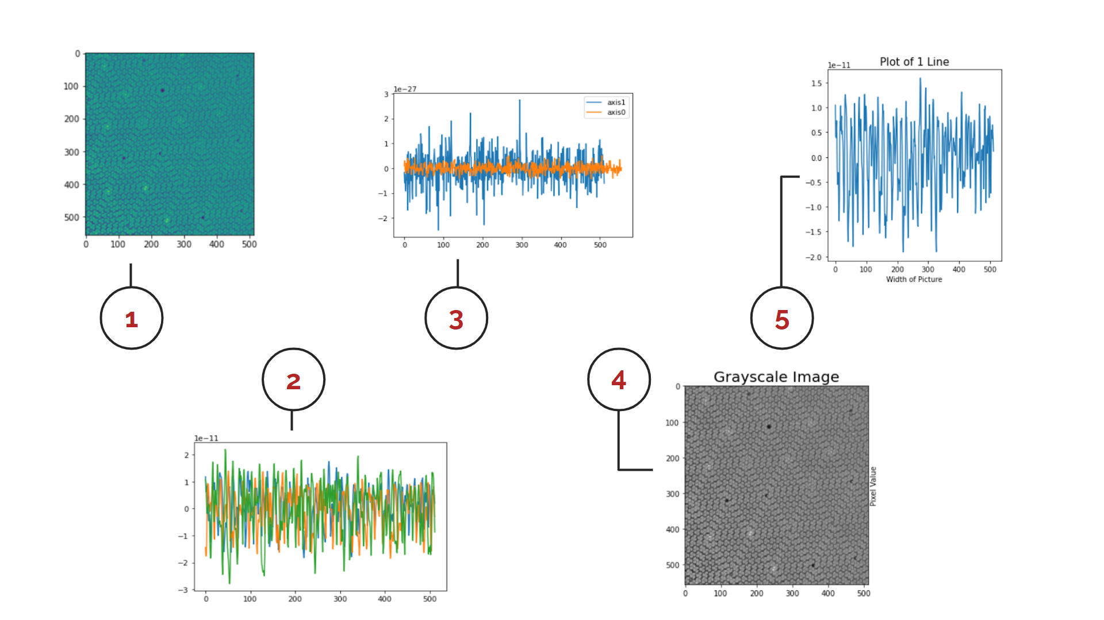

*Figure 2 data cleaning timeline*

Following this, the binarized image below does not have normalised values and it has the same dimensions as the original image. Additionally, the binarized image below is noisier than the original therefore blob detection cannot take place.

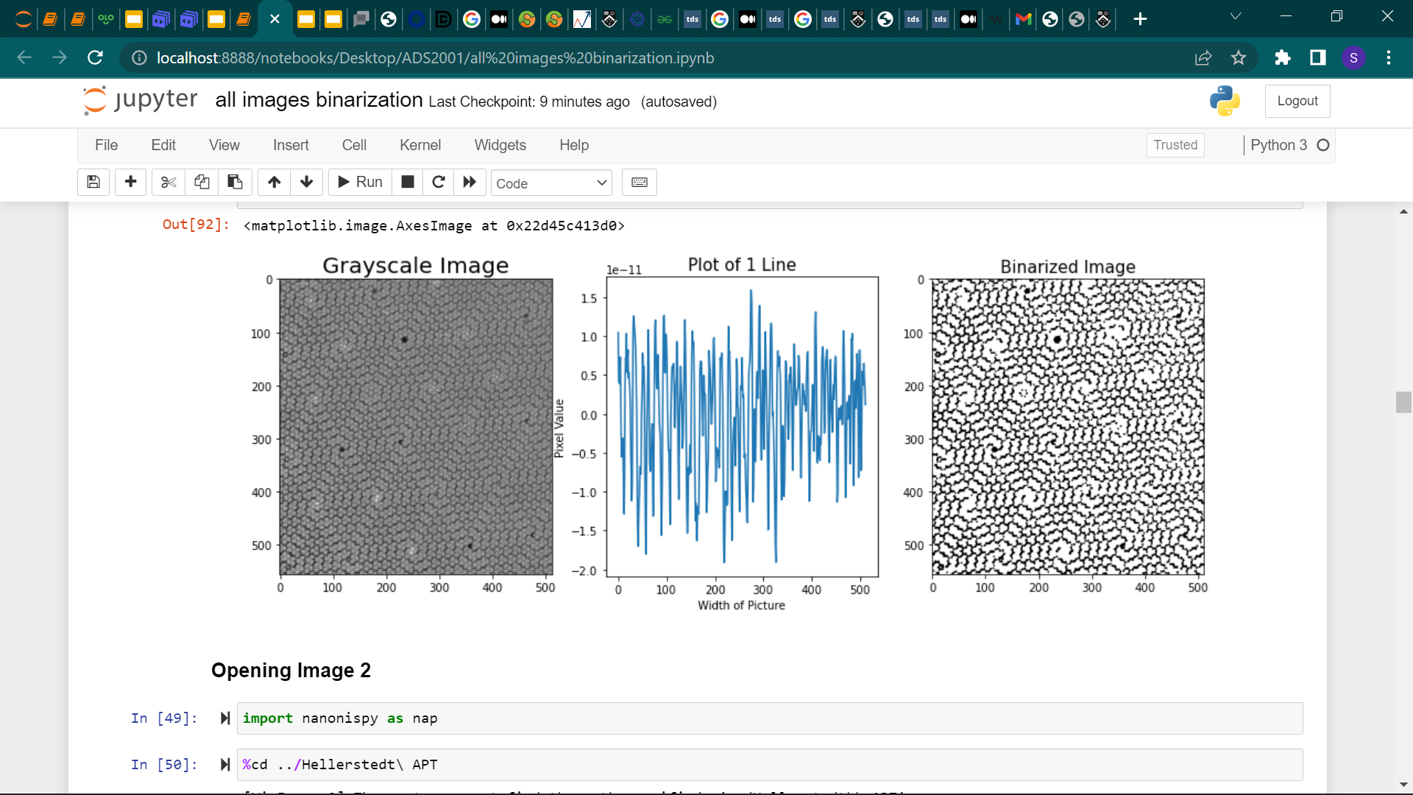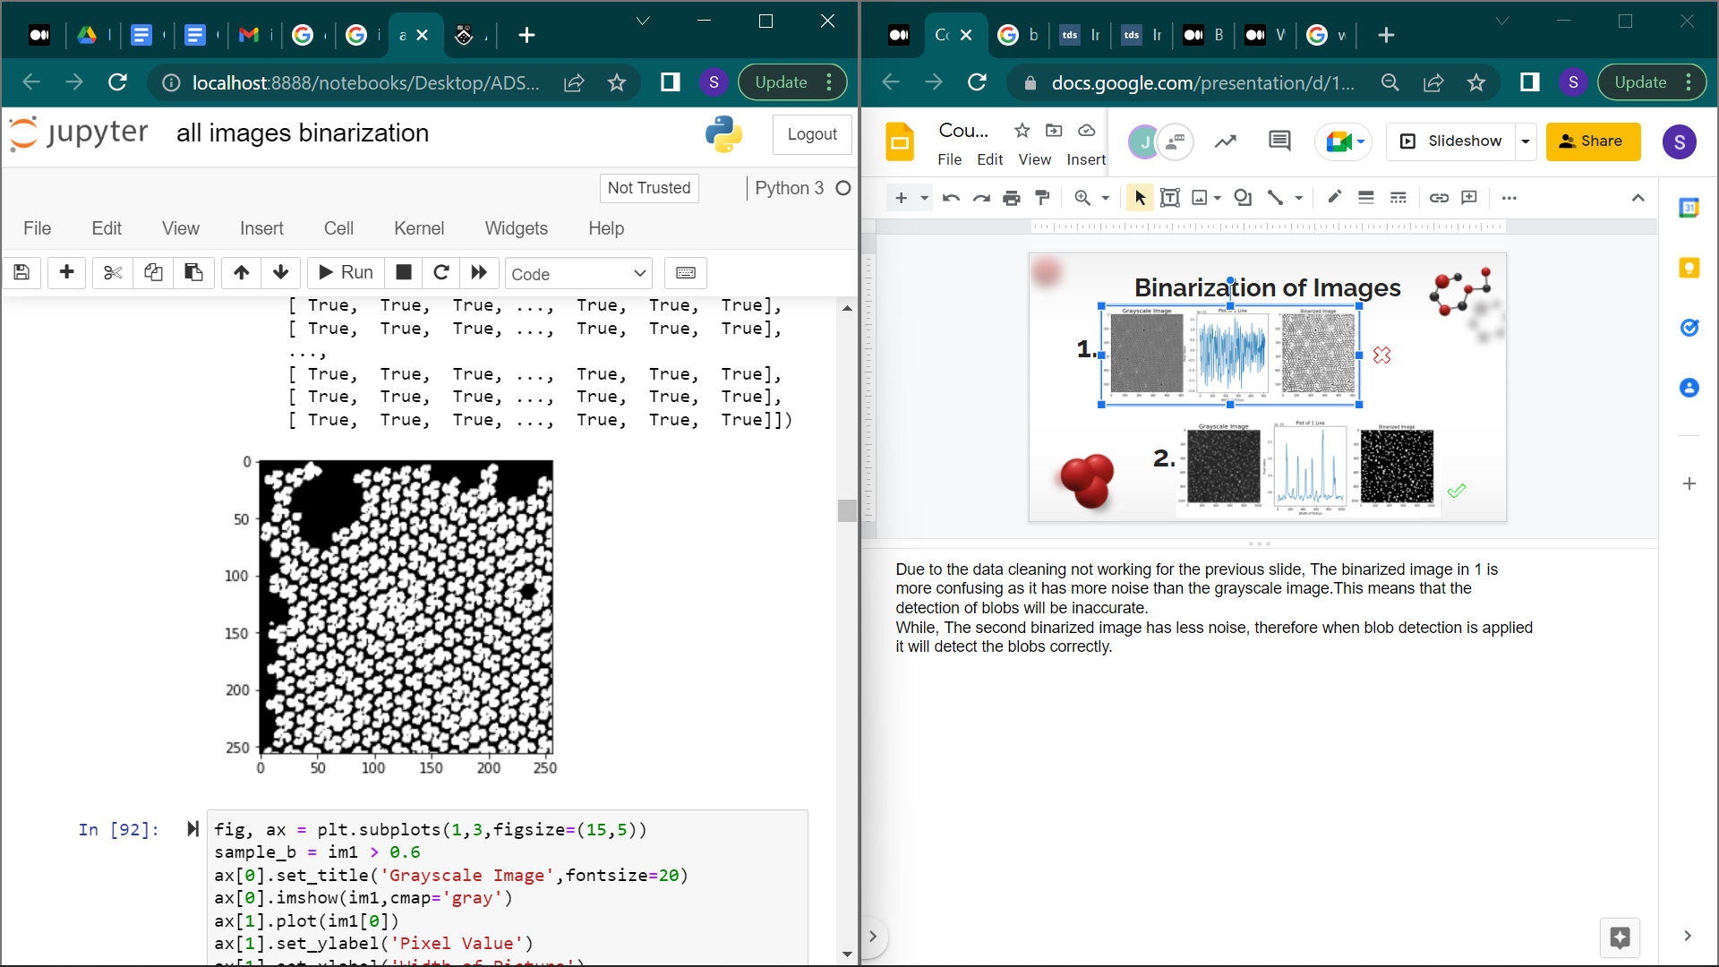

*Figure 3 binarization of the ‘unclean’ image.*

### Binarization of Images

When binarizing the images we used two techniques, a threshold_checker and Otsu’s method.

The threshold_checker iterates over several threshold levels and finds the optimum threshold to be used on the image. This ensures that the best mask is produced. The threshold_checker shows that the mask produced will be the same at any threshold. Thus, meaning that when binarized the threshold can be set from 0.1-1.0 and the binarization will be the same.

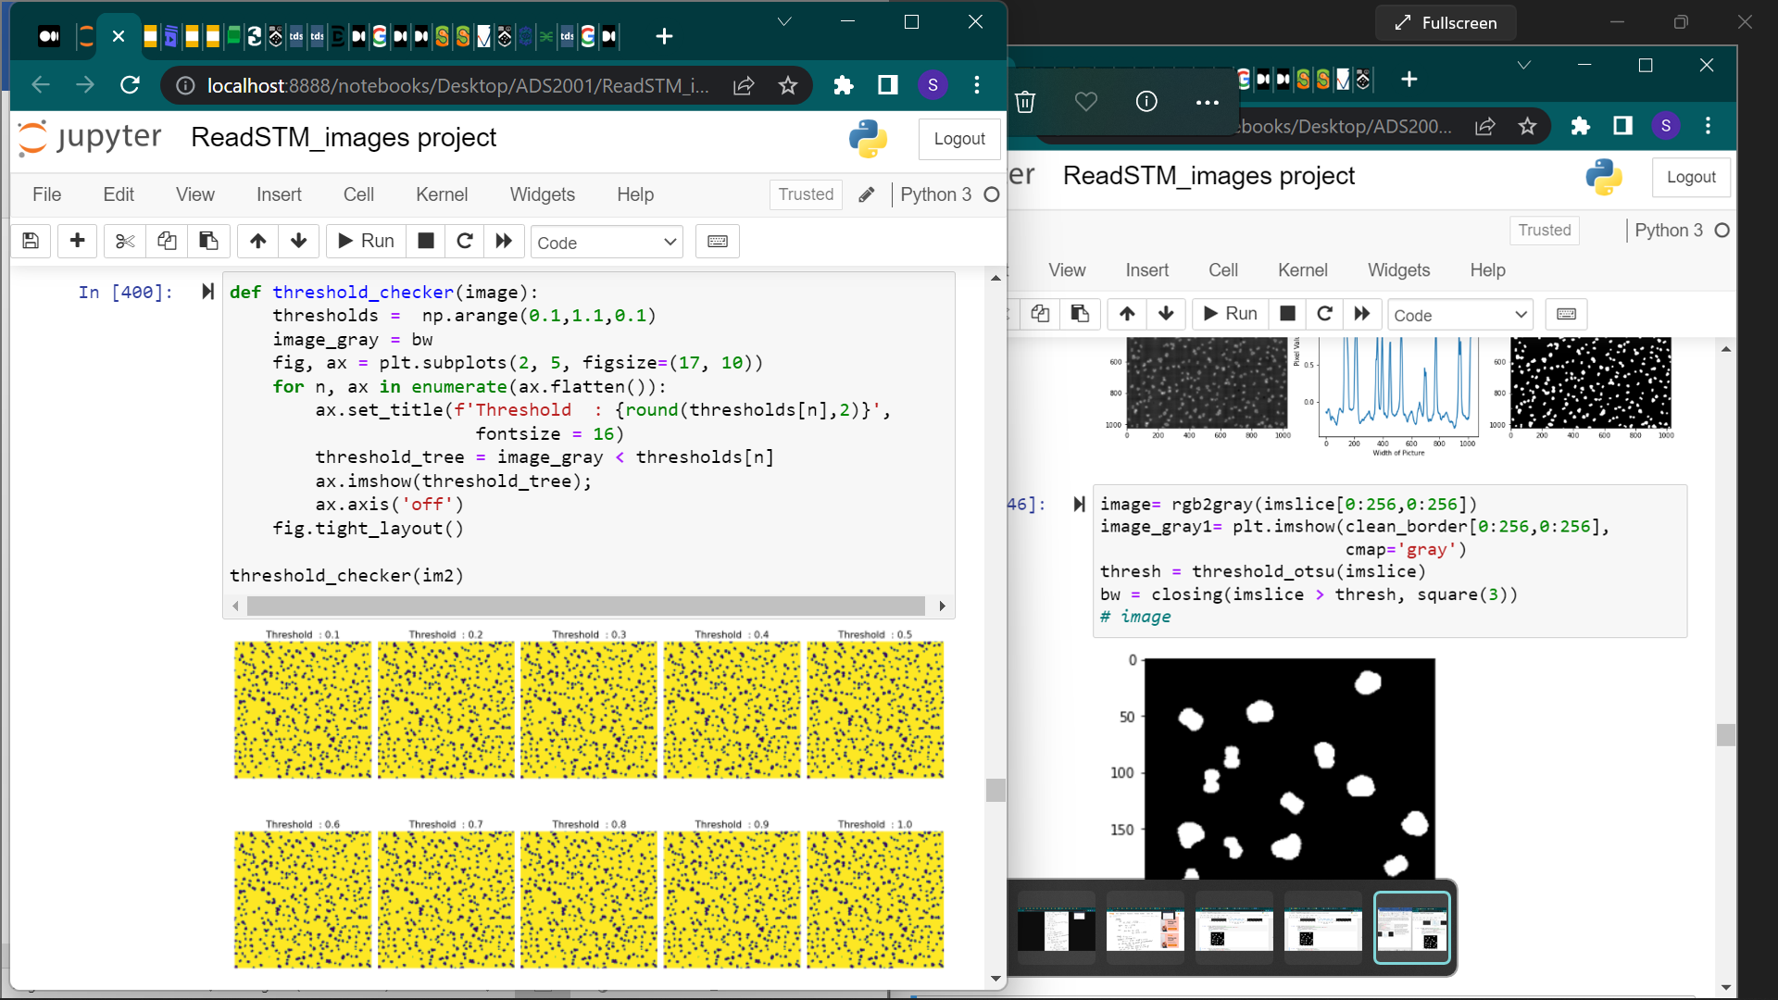

*Figure 4 Threshold checker*

We settled on a threshold on the pixel value of 0.6 because we can see on the plot of 1 line (sample plotline) that there is separation within this value. The binarization was done to decrease the noise and normalise the values so that the image is prepared for blob detection.

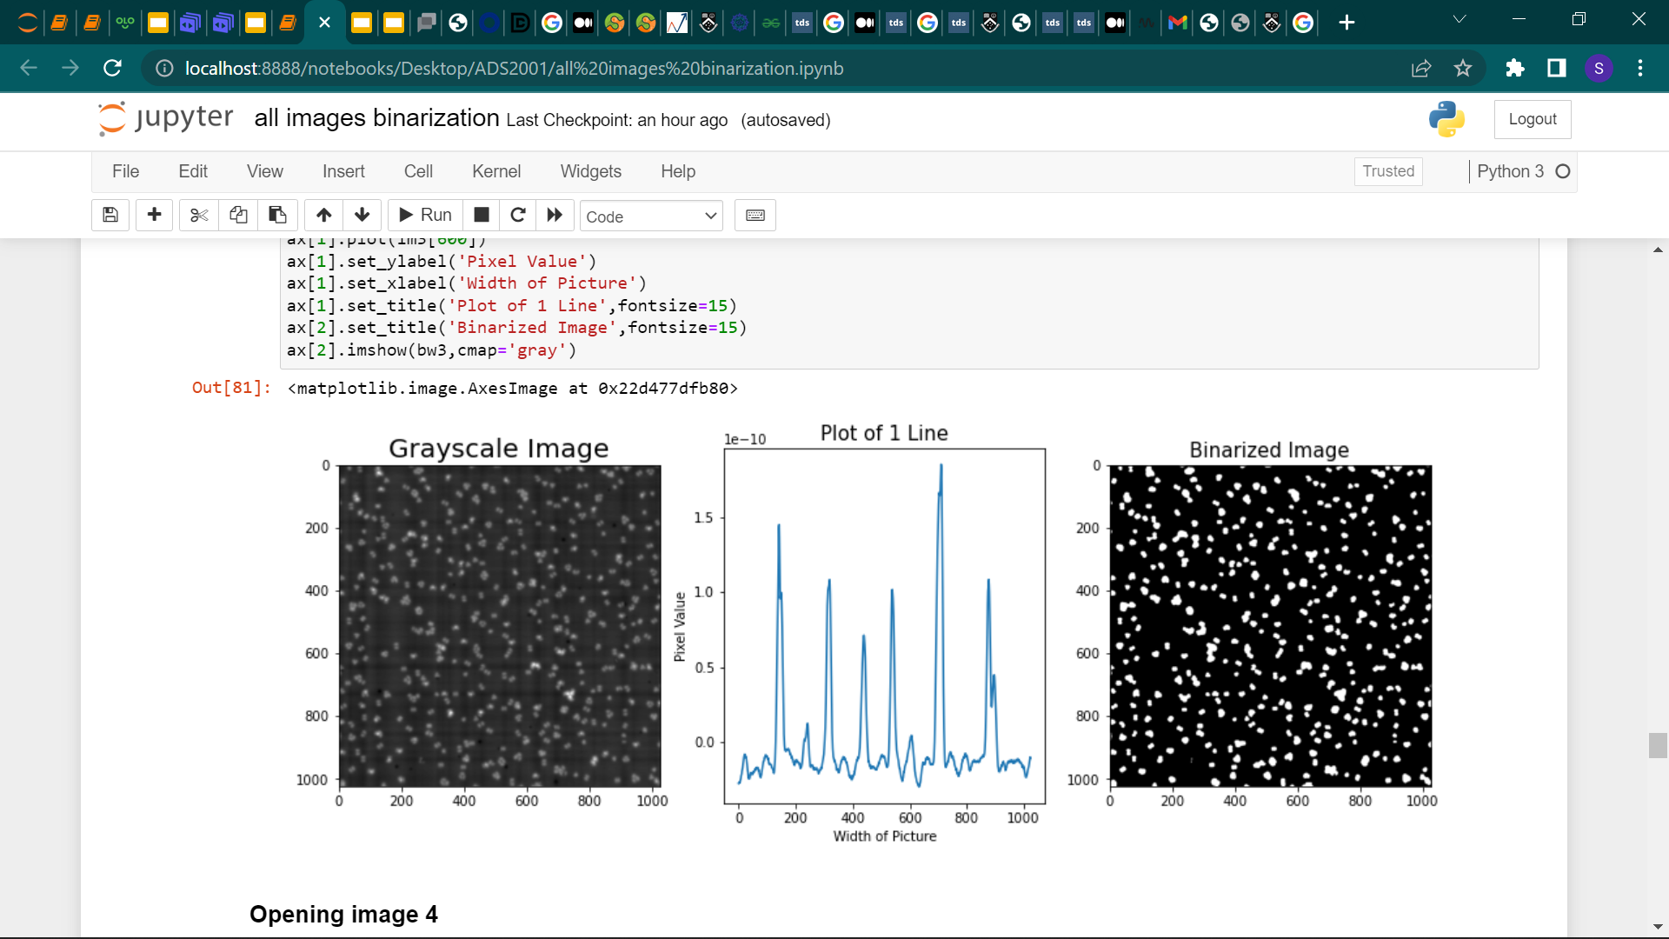

*Figure 4 Binarized image after successfully applying data cleaning*

The rgb2gray function was applied to convert the image’s channels into a single channel. This was to perform image thresholding to extract the important information of which, in this case, are the molecules. Since the images are a typical example of background-foreground, we used Otsu’s method to threshold the images. This worked for eight of ten images.

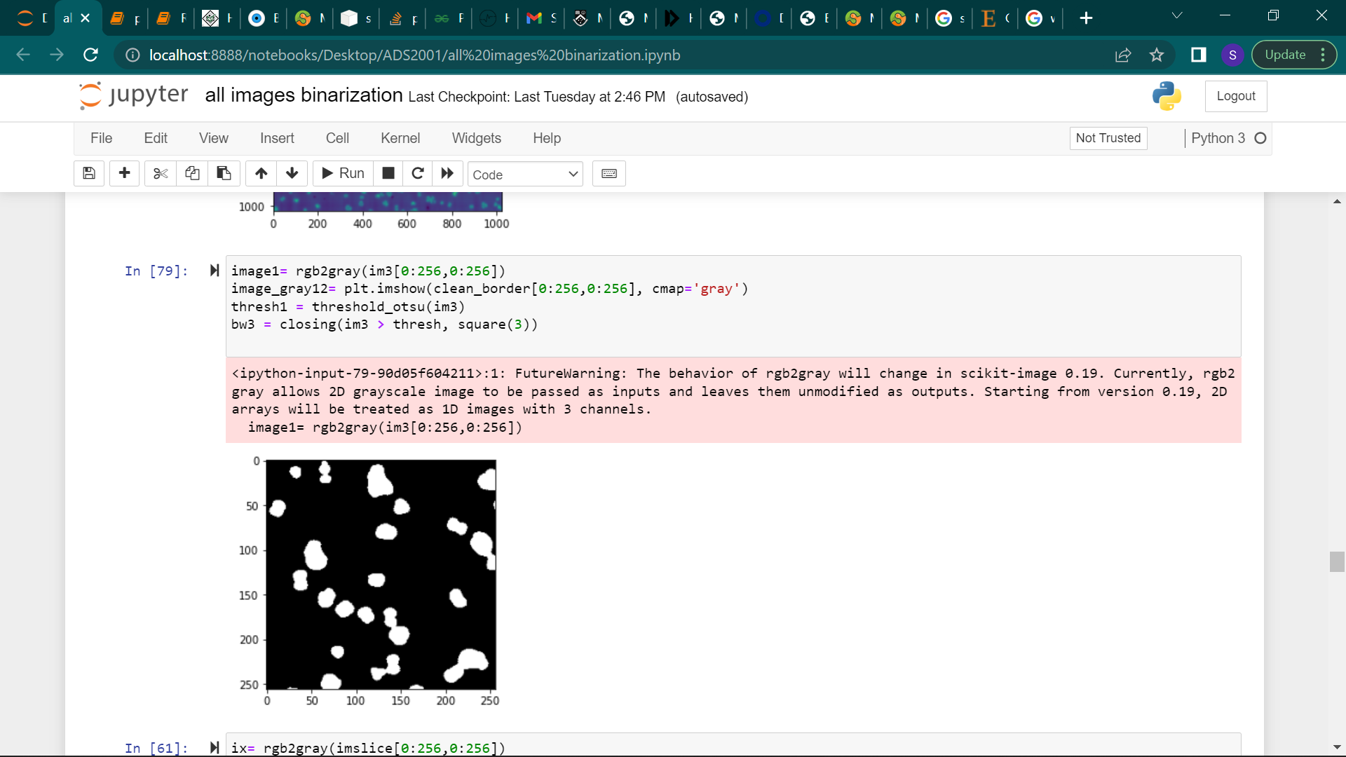

*Figure 5 binarized image using Otsu’s method*

When binarizing one particular image, we noticed that the binarization makes molecules that are close together appear as one as opposed to individual molecules as seen in the grayscale image below. The attempts to remedy this problem were futile as the binarized image did not change even after the threshold was continuously adjusted.

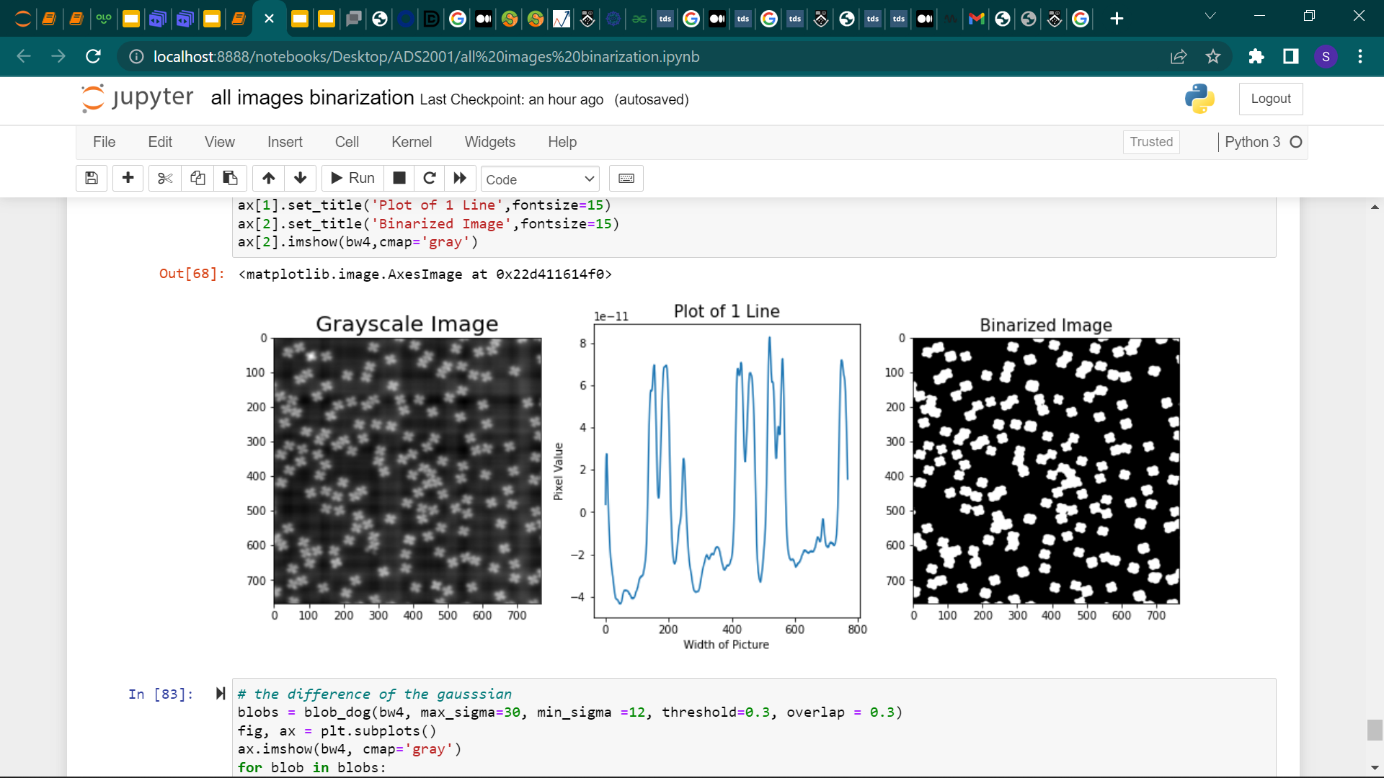

*Figure 6 Failed binarized image*

### Blob Detection.

We explored two techniques when doing blob detection: circular blob detection and connected component labelling algorithm.

Circular blob detection uses: the difference of Gaussian, the laplacian of the Gaussian or the difference of Hessian to detect blobs. Out of the three, we decided to use the difference of Gaussian as the laplacian of the Gaussian has too much overlapping so some molecules will be circled more than once causing inaccuracies when detecting blobs. While, the difference of Hessian does not detect any blobs at all even when the hyper parameters were continuously adjusted.

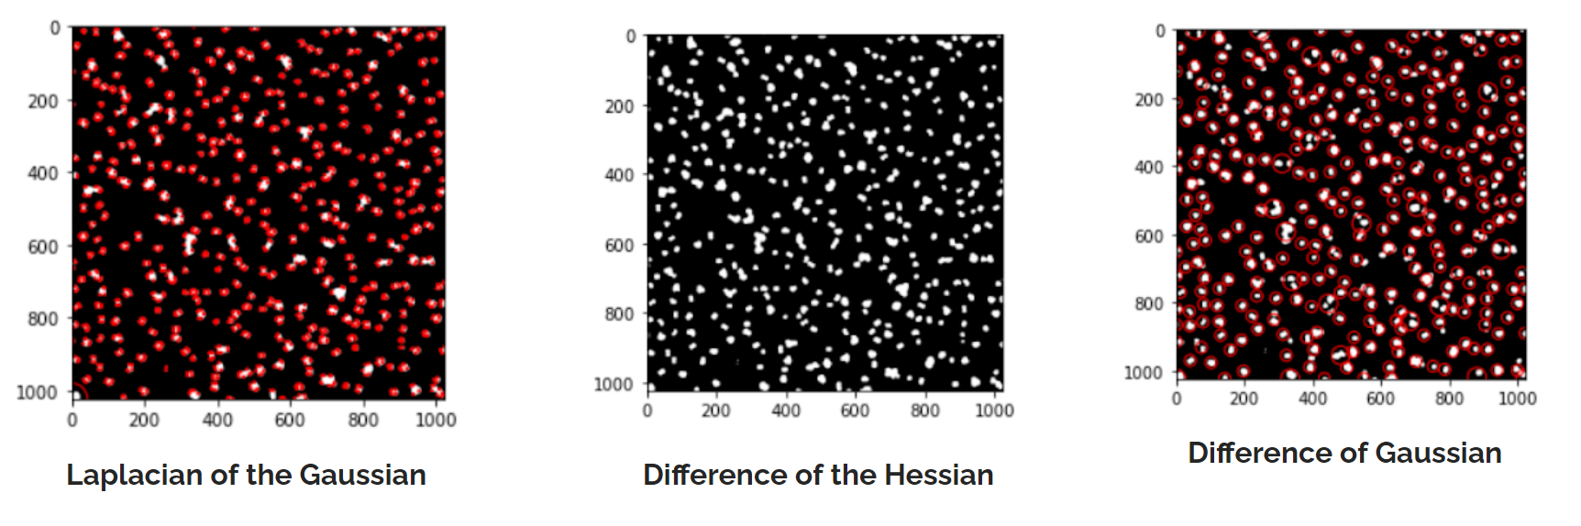

*Figure 7 Circular blob detection on image 1*

The connected component labelling function identifies all the regions of the image. This in turn simplifies the blob detection as it is able to segment, count the blobs and extract the properties from the image using region props. We settled on using this algorithm as it worked best to detect all the blobs and even displayed the number detected. The graph on the left has 87 blobs while the one on the right has 333 detected blobs.

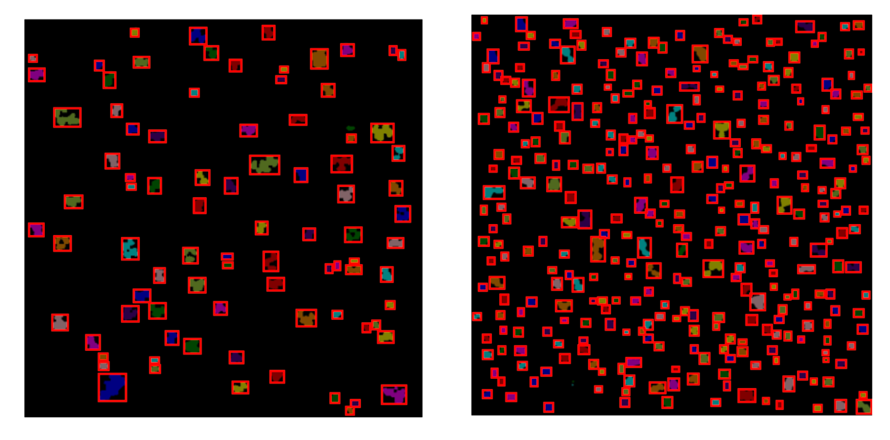

*Figure 8 blob detection using connected component labelling*

Using the regionprops_table we were able to find valuable and quantifiable features from the image to help us develop a classifier model. This is further explained in classification and clustering.

## **Classification and Clustering**

### Model Development

After we successfully label all the molecules, we can use the regionprop function to generate the data frame containing all the features about the molecules. Out of 17 properties, we pick 7 the most representative properties, area,perimeter,marjor_axis_length,minor_axis_length,solidity,euler_number and eccentricity.

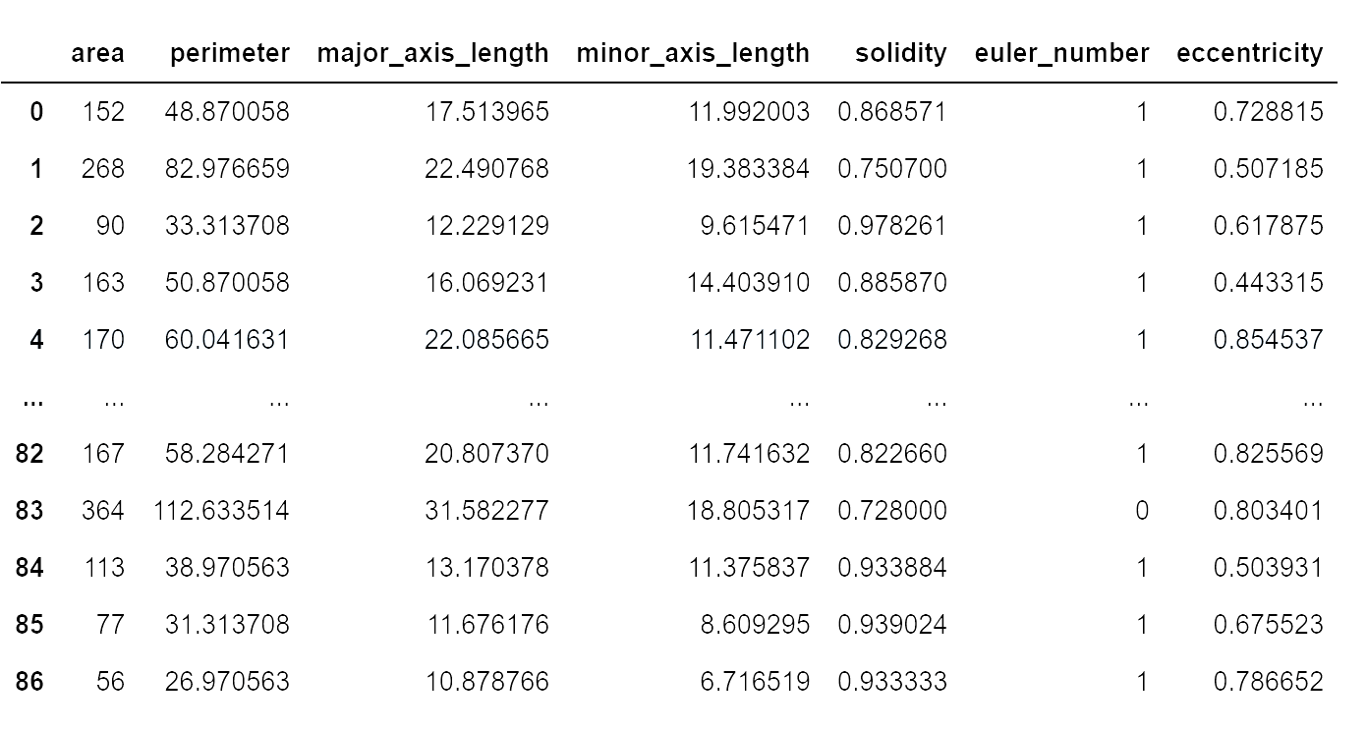

*Figure 9 data frame containing the properties of each blob*

Since this is an unsupervised problem we decided to use the k-means algorithm.The first step is finding the most appropriate number of clusters, we can achieve this by using the inertia score.

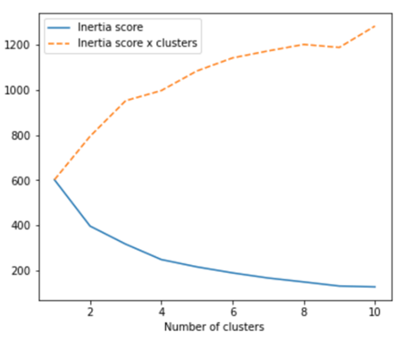

*Figure 10*

The result is not very good, if we focus on the orange dash line above the blue line we can see that the multiplication of inertia score and number of clusters goes higher and higher, the algorithm is not working very well.

In order to optimise the model, we decided to combine the PCA(Principal component analysis) with 2 components along with the k-means clustering in order to summarise the data information.

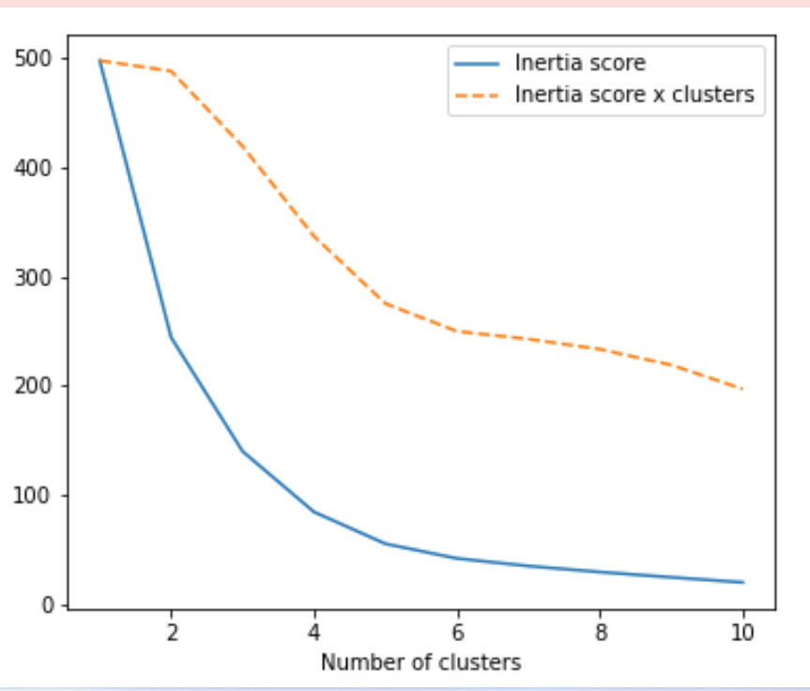

*Figure 11 PCA with 2 components*

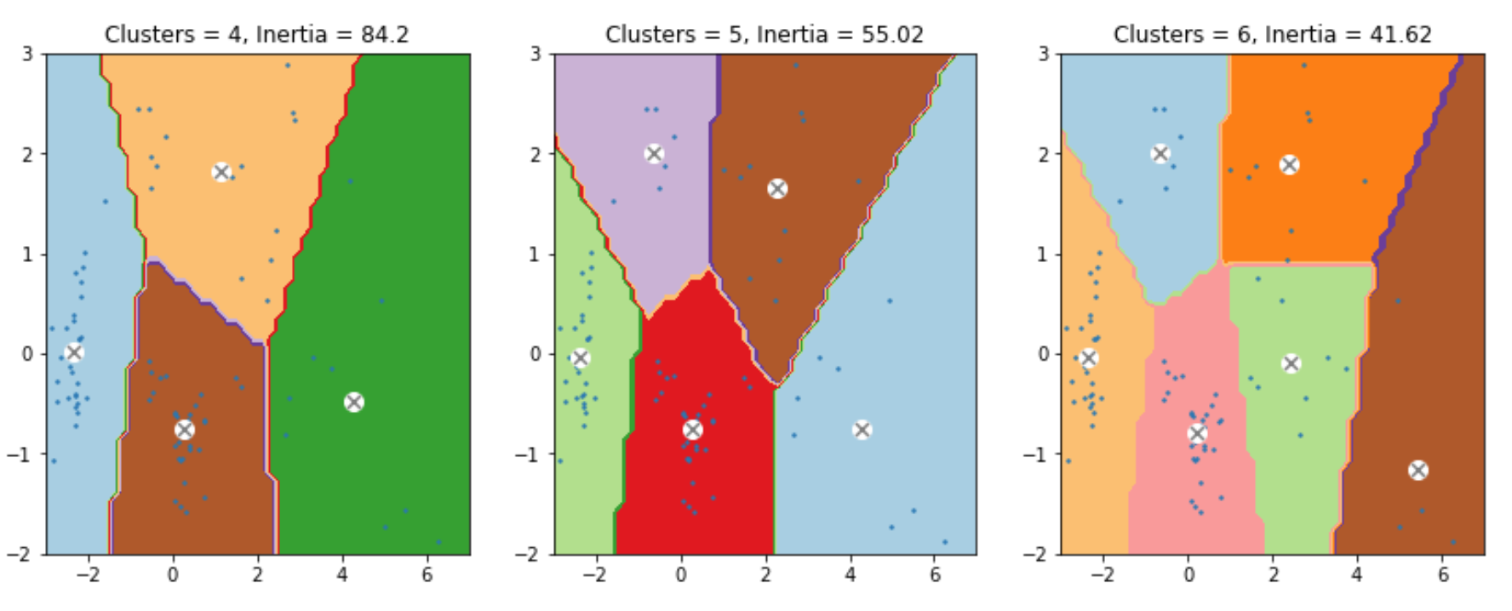 *Figure 12 Kmeans Clustering*

This new result is much more reasonable and according to the curve the most appropriate number of clusters should be 4 or 5. We decided to build two models and compare the results.

For the number of clusters = 4 the graphs are seen below.

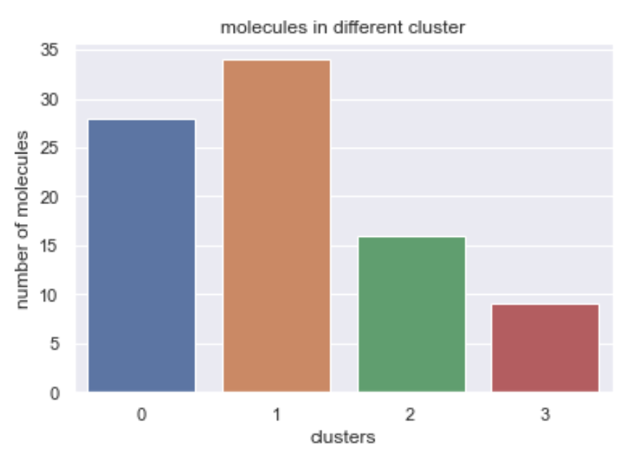

*Figure 13 Countplot of each cluster*

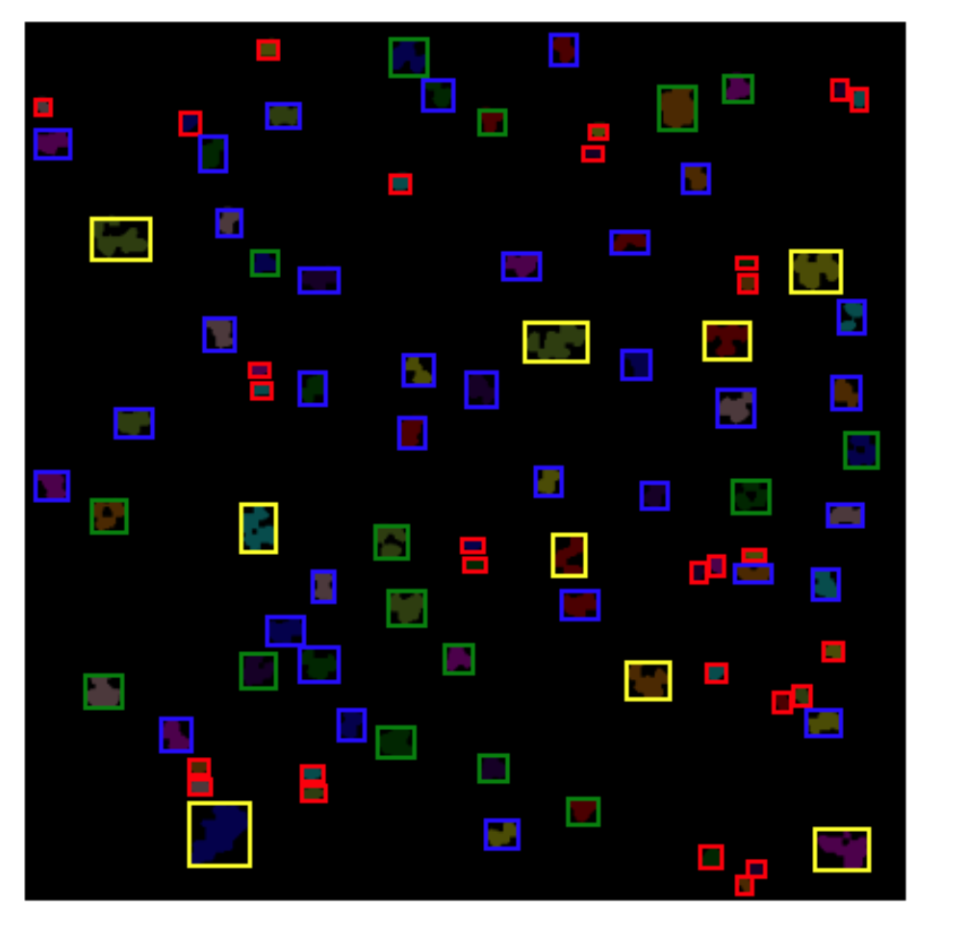

*Figure 14 plot of all the molecules with different colours representing different clusters.*

For the number of clusters=5 the graphs are seen below.

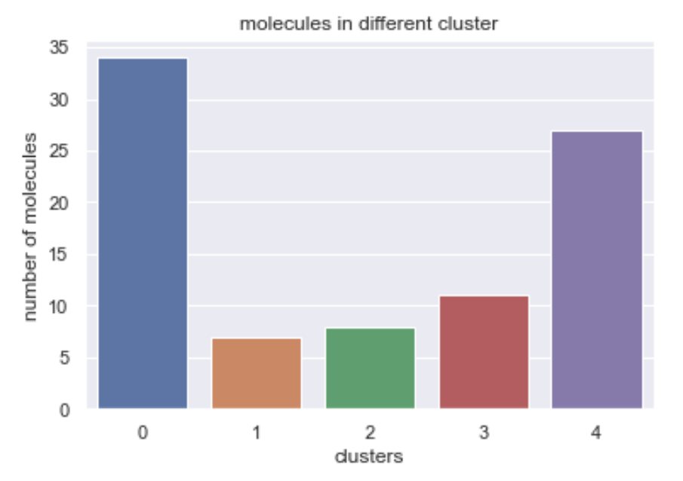

*Figure 15 Countplot of each cluster*

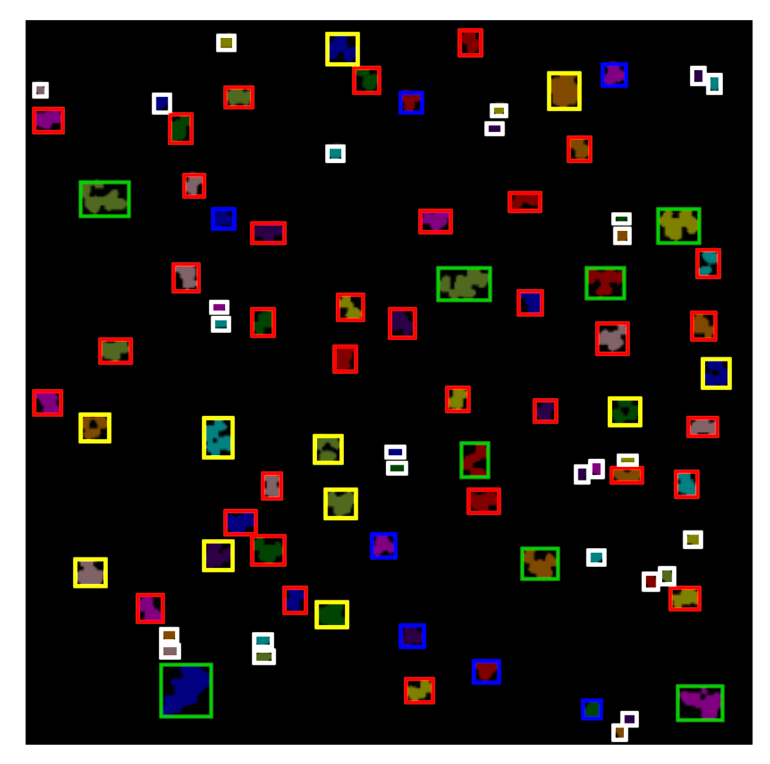

*Figure 16 plot of all the molecules with different colours representing different clusters.*

Finally we compare the accuracy of the two models by randomly selecting different molecules in each cluster.

For a certain group in number=4 model

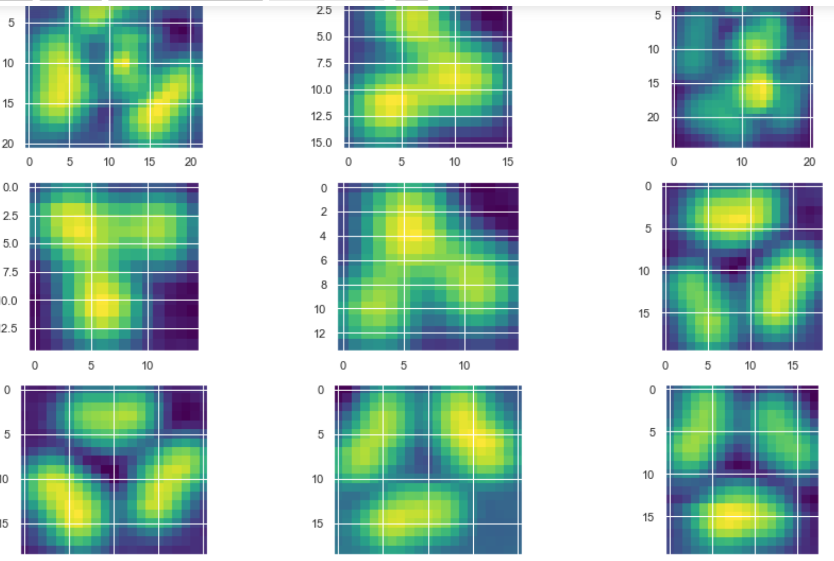

*Figure 17 subimage of a single molecule for four clusters.*

There are clearly two different types of molecules in the graph above.

Same group in number=5 model

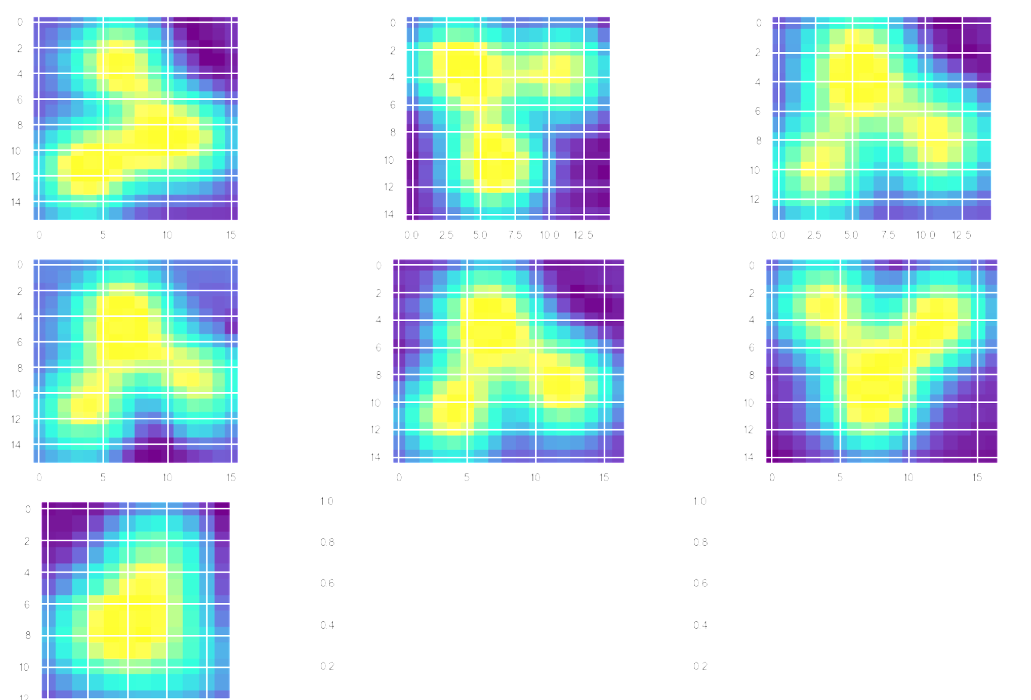

*Figure 18 subimage of a single molecule for 5 clusters.*

One can see that Six of the molecules are exactly the same.

# **Results**

As seen above, the model with 5 clusters has a much better result. During the process we can see the boundaries stop changing after 3 iterations

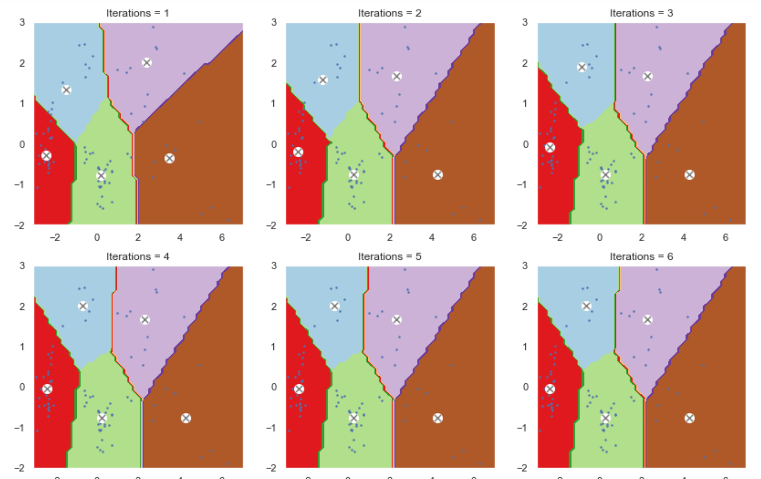

*Figure 19.*

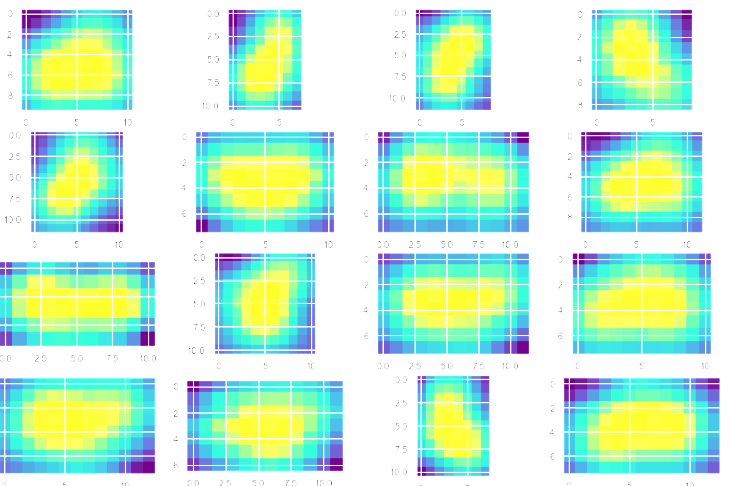

*Figure 20 cluster number 4*

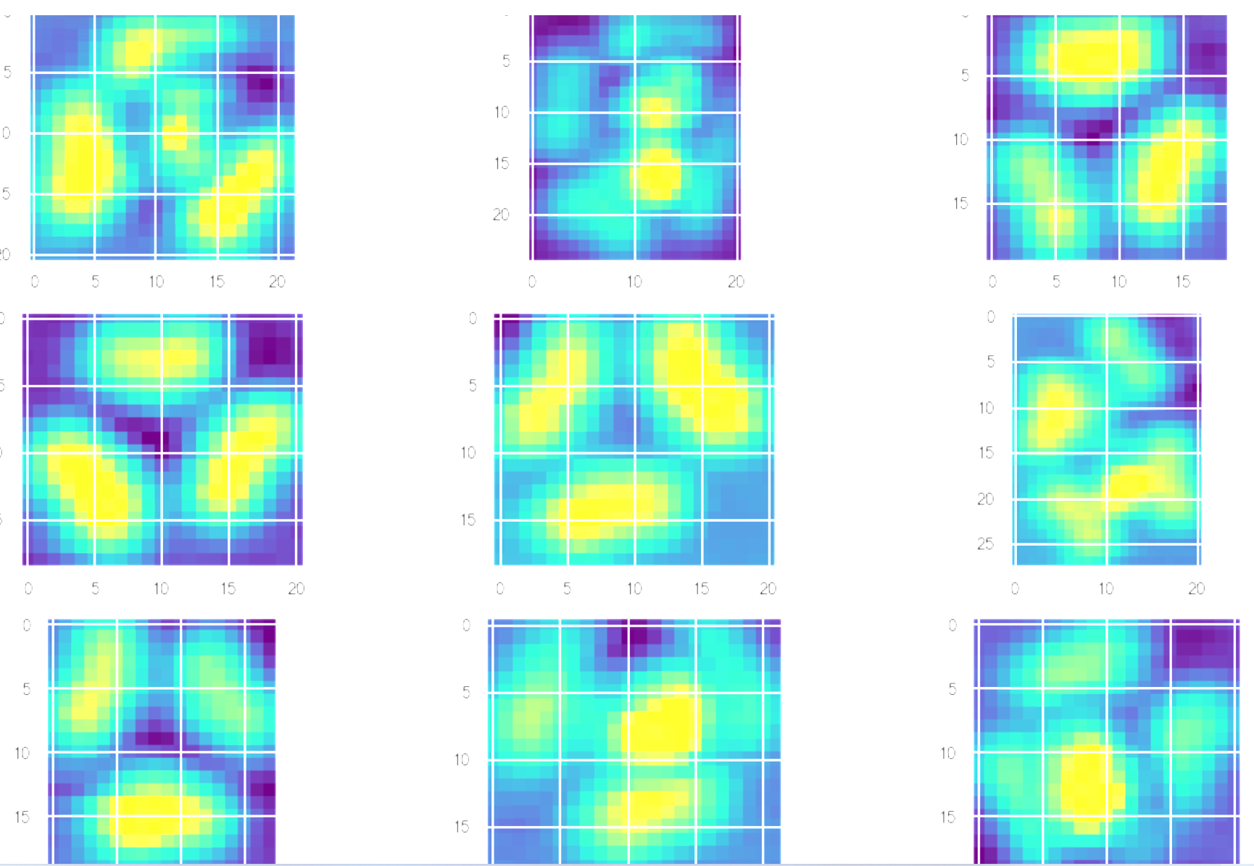

*Figure 20 cluster number 3*

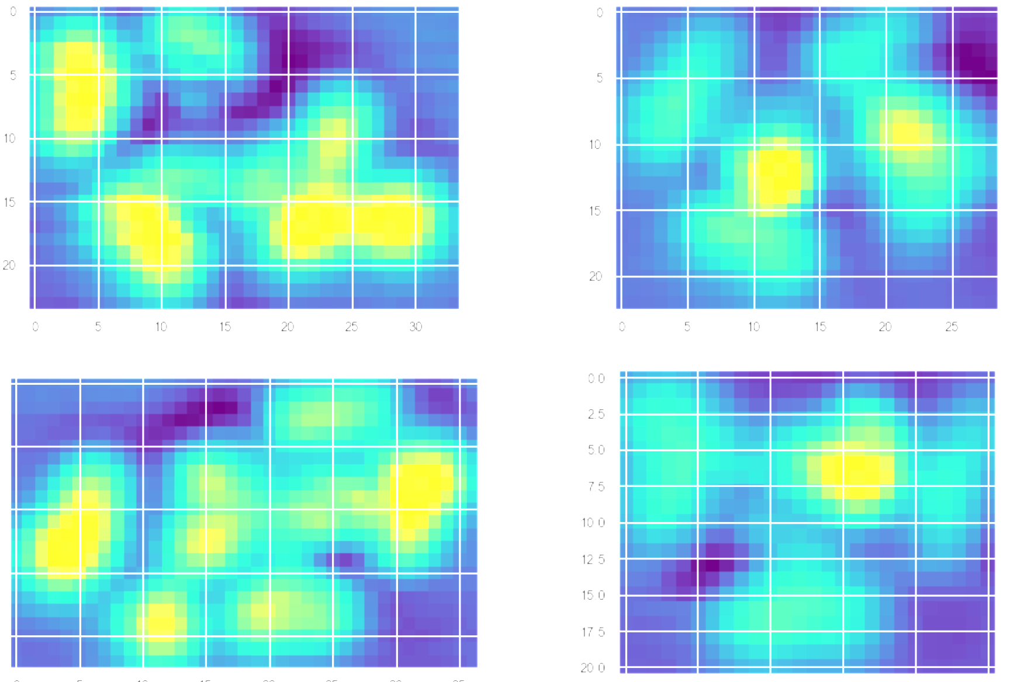

*Figure 21 cluster number 2*

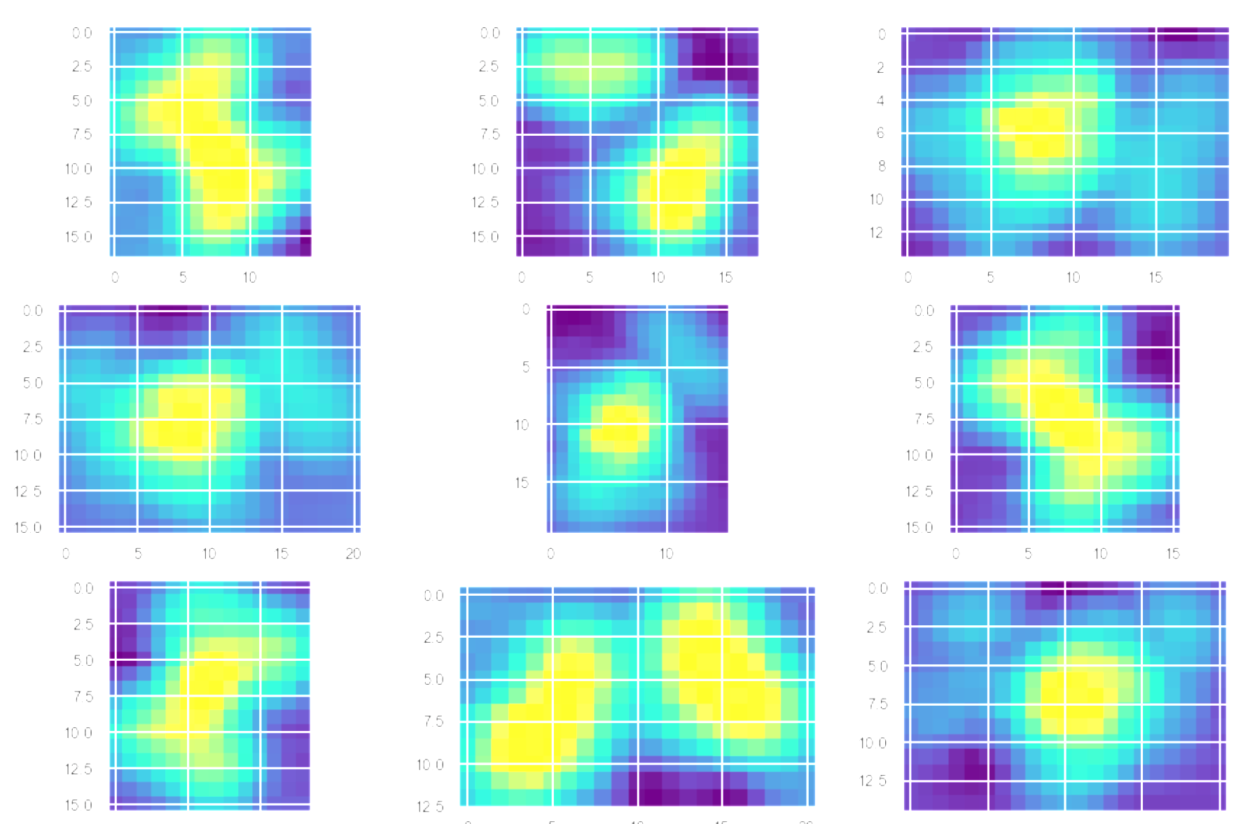

*Figure 22 cluster number 1.*



*Figure 23 cluster number 0*

We can observe that in cluster number 4 most of the molecules are the same although some of them are pointing different directions.In cluster number 3 there are all rose-petal-shaped molecules. In cluster number 2 all the molecules are irregular and have large size. In cluster number 1 the accuracy is not very good, it should be further separated into two different clusters. But in order to remain the result in other clusters and be consistent with the inertia score we decided to keep using the model with 5 clusters. In cluster number 0 the accuracy is very high.

# **Conclusion**

We apply the same process on every image and get the similar result.From this specific image, we find that combining k-means-clustering with 5 clusters and PCA with 2 components gives the best result.The algorithm can detect all the molecules and have a 70% accuracy in the clustering.

Overall, we classified the molecules into 5 clusters and if we randomly select molecules in each cluster we can see that for cluster 4 ,3 and 0 there’s a good accuracy but molecules in cluster 1 should be further separated into two different clusters based on their shape.Whereas Cluster 2 only has irregular, large-sized molecules therefore, we do not recommend using it.

# **Appendix**

[ADS2001 / Counting Molecules · GitLab (monash.edu)](https://git.infotech.monash.edu/ads20011/counting-molecules)